DigiMe – Student film
Brno elementary school, Krásného 24

Contents:
Project goal 3
Team selection 3
Technical team 4
Screenplay 5
Actors 5
Equipment 5
Process 7
Planning 7
Camera rehearsals 8
The main shooting schedule 9
Mastering and post-production 10
Conclusion 11

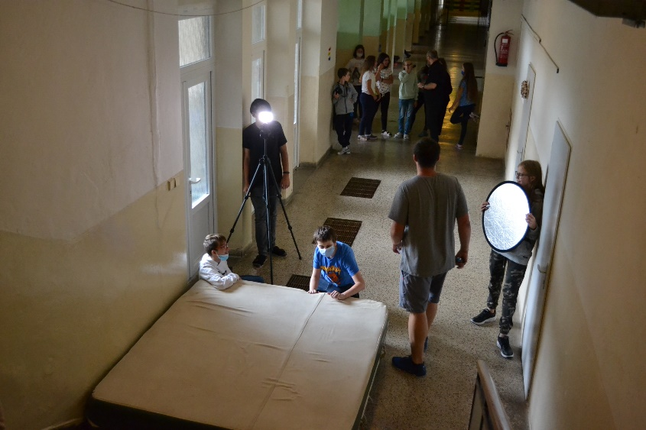

Project goal
The goal of the project was to teach students to create short videos using modern technologies so that they would get a basis for their own creations. At the same time, the creation of a video presenting how to do the basics of first aid in a simple form so that even elementary school students would be able to understand and use it. The creation of the video was technically challenging and time-consuming. During the filming, the students flew a drone, even though the images from the drone were used to develop a car accident video outside of the DigiMe competition. The course of preparation and filming took place as follows.

Team selection
First, it was necessary to secure several team groups among the pupils. The project started a year earlier, so during the preparations and because of the epidemiological situation, we were forced to change the team. The original team consisted of ninth-graders, who, however, transferred to secondary schools during the closing of schools.
The team was divided into the following groups:
- Technical team
- Screenwriters
- Actors
- Cameramen
- Post production

Technical team
The technical team took care of filming, sound and lighting equipment. These students were thoroughly introduced to the equipment and trained in the basic principles of handling technology for recording video, sound and subsequent editing. Whilst working on the project, the students made several practice shots, on which they tested the lighting, working with video cameras and regular cameras, recording the sound track and subsequent editing and cutting. After these trial attempts, the shooting of the video itself began.
.
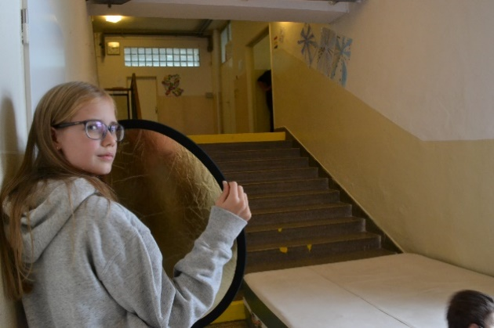

Screenplay
The organisational team was involved in the actual preparation of the scenario and the selection of the location. The original plan was to shoot more instructional videos with the basics of first aid, but due to the epidemiological situation it was necessary to adjust the plans. Therefore, some scenarios remained unused for the project, but the plan is to continue working with them in the future.
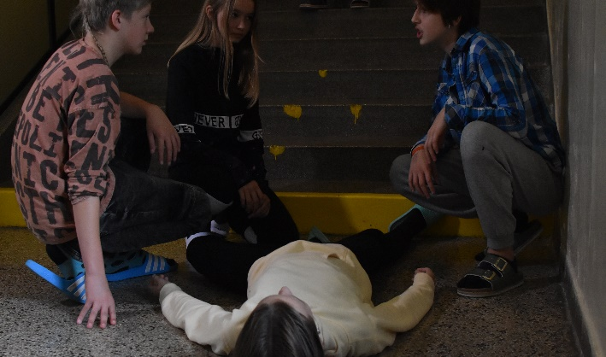

Actors
The last team was made up of student "actors", who received a script and, according to it, prepared the entire course of the shooting scene with the organisational team. This team itself was divided into two groups, the main protagonists and the extras.

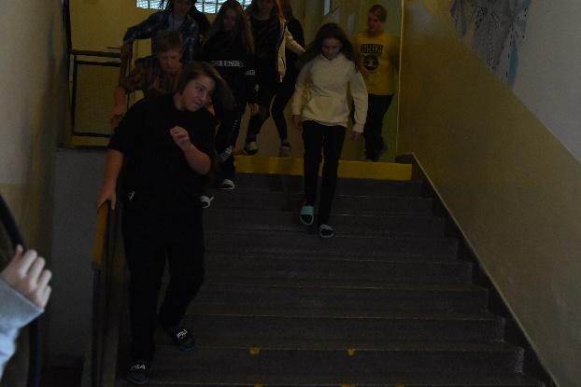
Equipment
Filming took place on a Sony UHD 4K FDR-AX33 camera, photo cameras and a DJi Osmo Pocket sports camera were used for photo and video documentation of the progress of main shoot, the Pinacle studio program was used for video editing. Rode NTG 1 microphone and Tascam DR 70d were used for sound recording. Studio One 5 was used for sound editing, mastering and cutting.

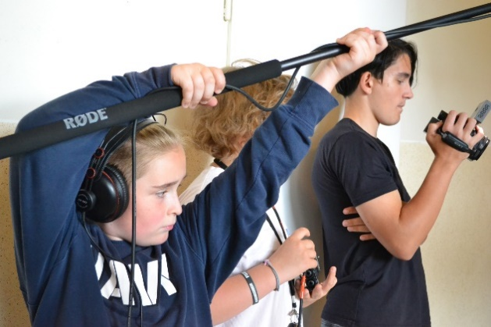

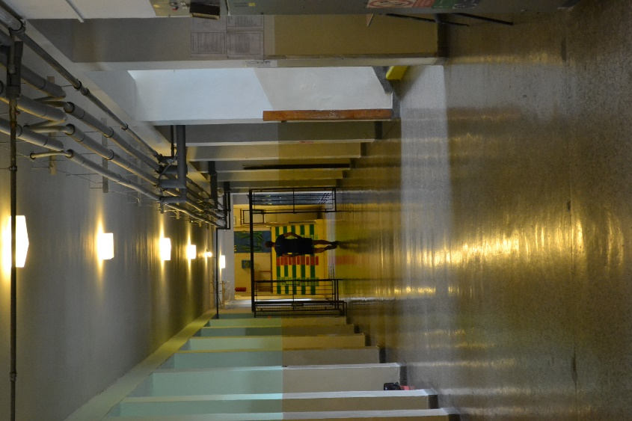

Process

Planning
The students first went through the school premises and marked out the locations where the filming process would take place. They determined the starting position, the final position and the path between these positions. The locations were chosen with great consistency, as the filming took place during classes and it was therefore important to plan the route so that the filming process itself would not disturb other pupils in the school.
Some effects required safety considerations, with actors running down corridors, stairs, and even falling down stairs. During the filming of the stunts, it was necessary to monitor and plan everything in detail. These shots were shot many times as it was a risky part and the actors pushed their limits gradually.

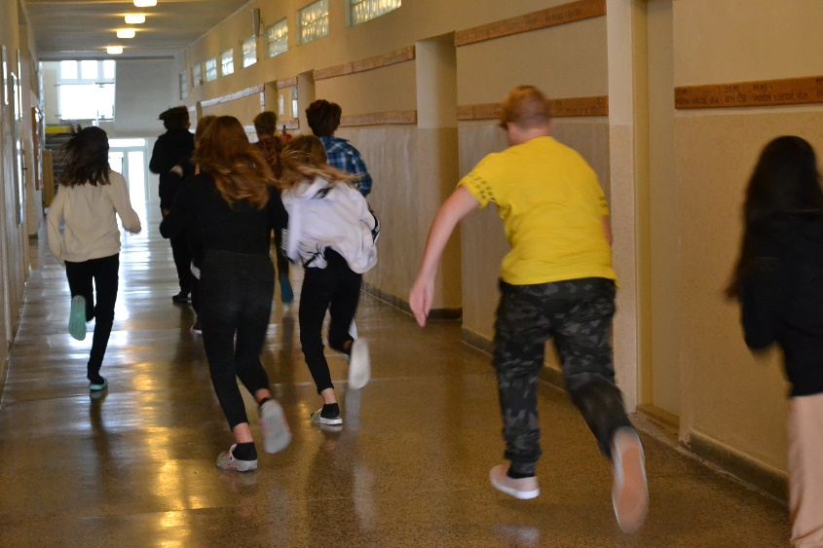

Camera rehearsals
Camera Rehearsals – students 'actors' walked through parts of a scripted route to give the technical team an idea of ​​the space, light and camera angles. Quite often they ran into backlight problems, which could not be solved perfectly every time.

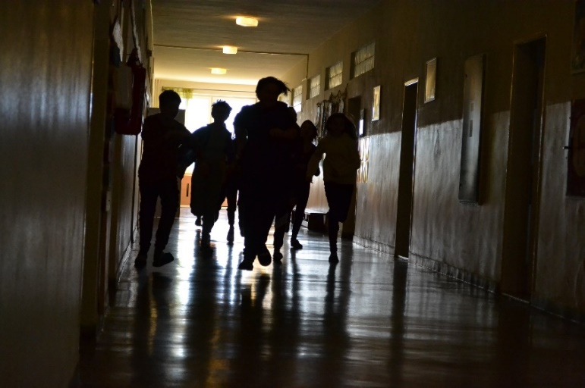
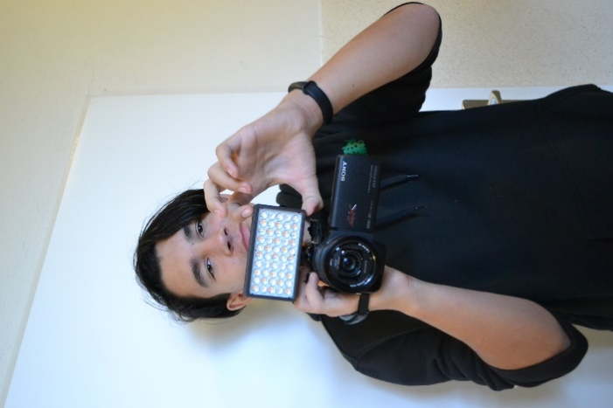

The main shooting schedule
The entire filming process was divided into individual filming sections. Each section was filmed several times, each time from a different camera angle to obtain a more dynamic image. Since it was filmed during classes, there was a limited amount of time for each scene. So sometimes one scene was filmed throughout several lessons divided into several days.

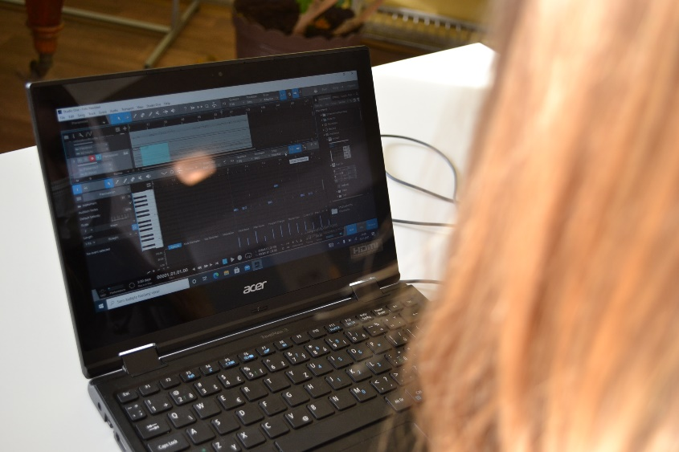

Mastering and post-production

Video editing
After the completion of all the shooting scenes, the material was handed over to the students, who edited the video (exposure, color, sharpness,…) and cut the video so that it fits the script through time. In addition to this final phase, they focused on the creation of the introductory video, to which the soundtrack was subsequently added.

Sound editing
Other students edited the audio tracks, which were simultaneously recorded with the main shooting on an external audio device for a better and cleaner sound recording. The external audio track needed to be cleaned of ambient noise, and needed addition of equalisation and volume normalisation. The audio was then added to the video, replacing the poorer audio quality of the recording, which was recorded with a microphone directly from the camera. But it didn't end there for our masters of sound. The biggest task was to create and record a jingle for our project. This process took most of the time. The DAW program Studio One was used to create the jingle with the help of MIDI keys. The idea of ​​the jingle corresponded with the vision and character of the filmed project. The music was then inserted directly into the opening video.

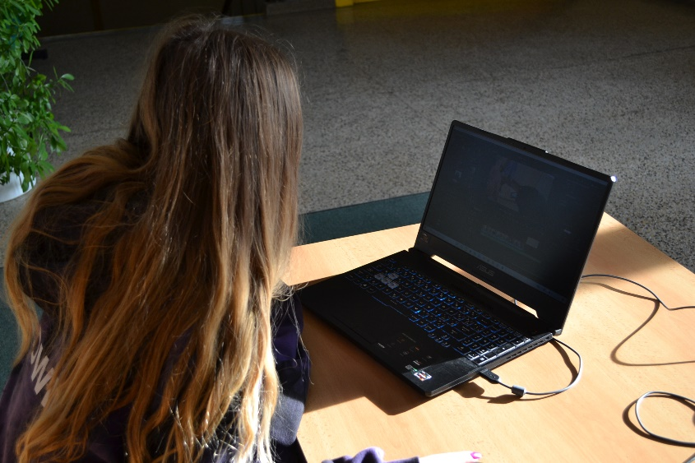

Conclusion
Due to the coronavirus epidemic, the implementation of the project was complicated, as the team of pupils had to change during the first year and the school was closed. Shooting was difficult even after the students returned to school, because the team could not meet
at regular meetings because of the epidemiological regulations. Communication between the pupils and the project management took place remotely via internet communication channels, pupils processed and created ideas, thoughts and their observations at home. The whole process was made more difficult because it was not possible to rehearse directly at the filming location (in our case on the premises of the school), and the students had to create a scenario based on an imaginary idea of ​​the premises of the building.
Thanks to the loosening of the covid regulations and the return of pupils to schools, we were able to continue the project face-to-face. As a result, the project was also very beneficial and fun for the students. They especially appreciated the opportunity to try out technologies that they wouldn't in most cases encounter on their own. For some, it was a big challenge, especially for those who subsequently edited videos, cut sound in post-production, or even tried their hand at composing a musical jingle. We believe that it was a great experience for the student team. An experience they will be happy to remember for a long time and draw on in the future. It certainly does not end with this project and we are convinced that it is a certain motivation for future generations of students who would like to penetrate the behind-the-scenes secrets of preparing, shooting and editing video and sound.

